Practical-2

DBMS LAB

AIM: Create a student table (roll_no, name, department, marks) and write the queries to carry out the following:

1. Create the table

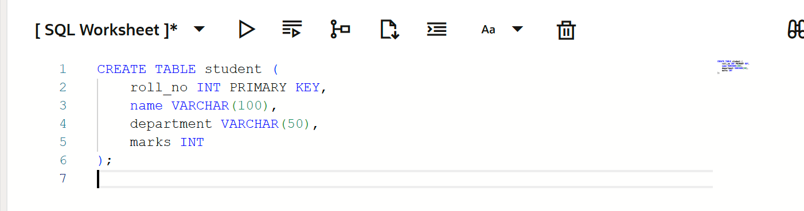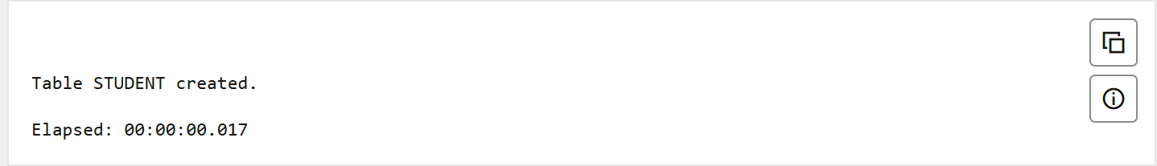

2. Run desc student to check the structure of the table.

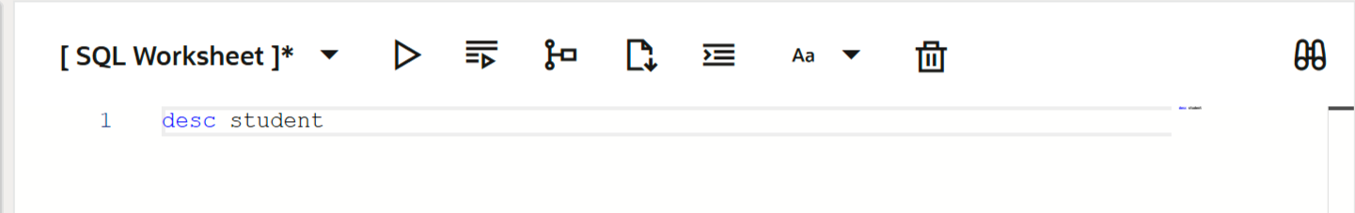

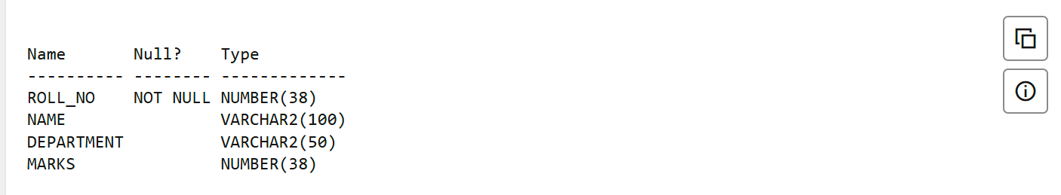

3. Insert 20 rows in the table

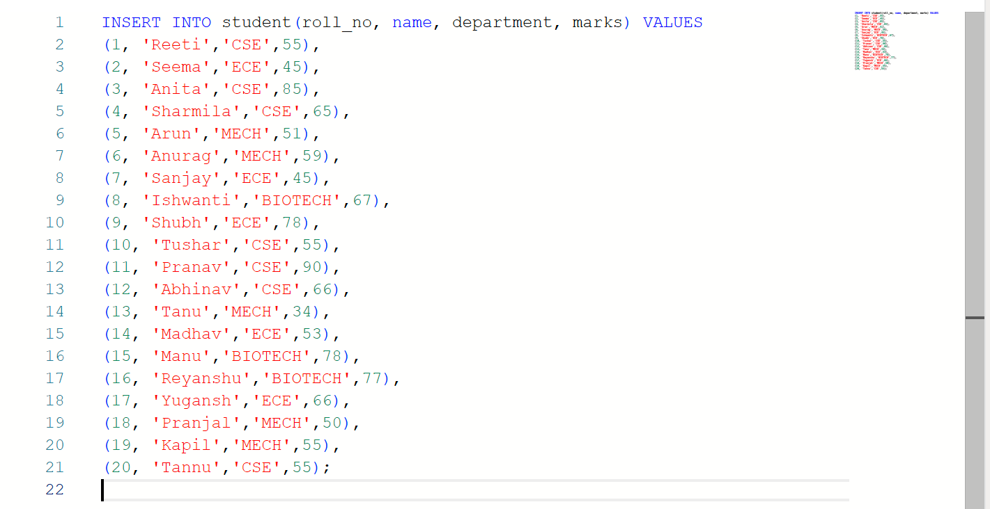

4. View the complete table

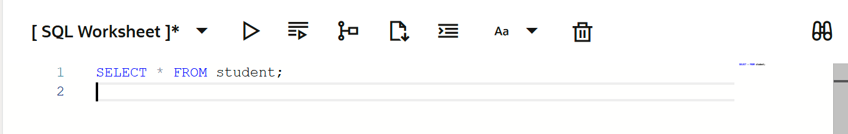

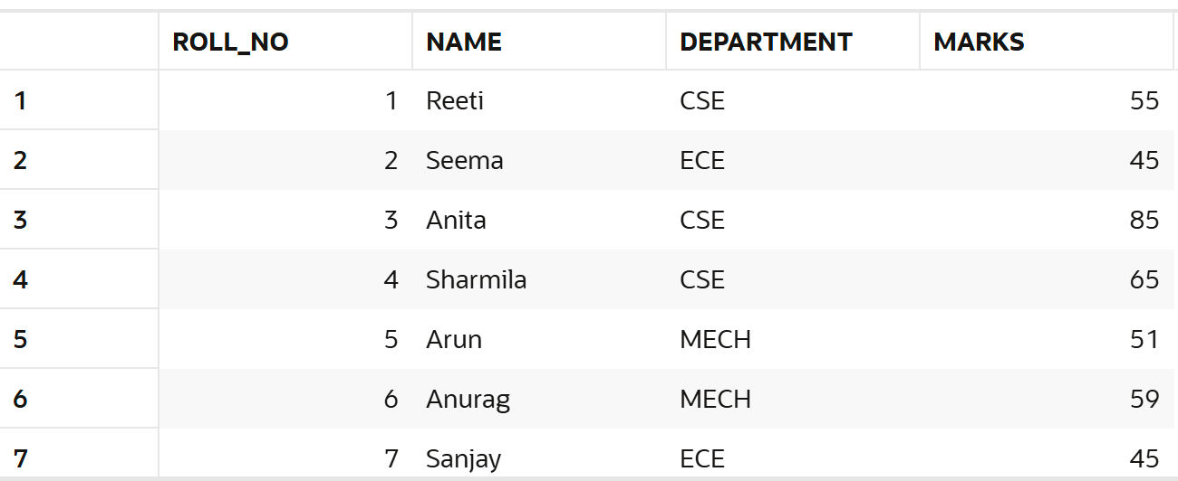

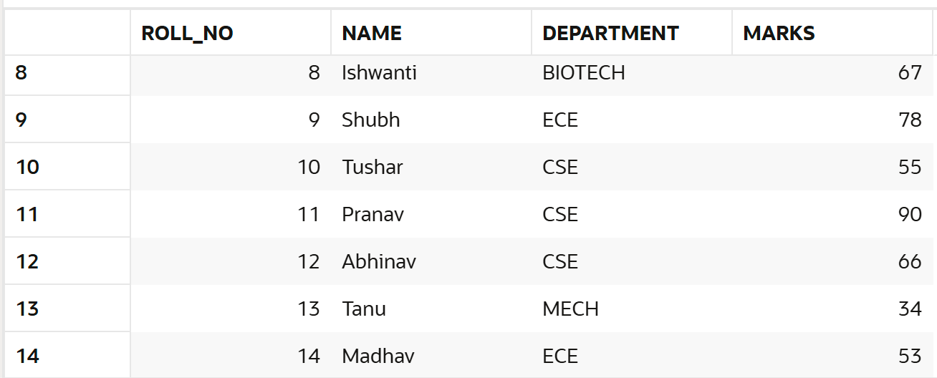

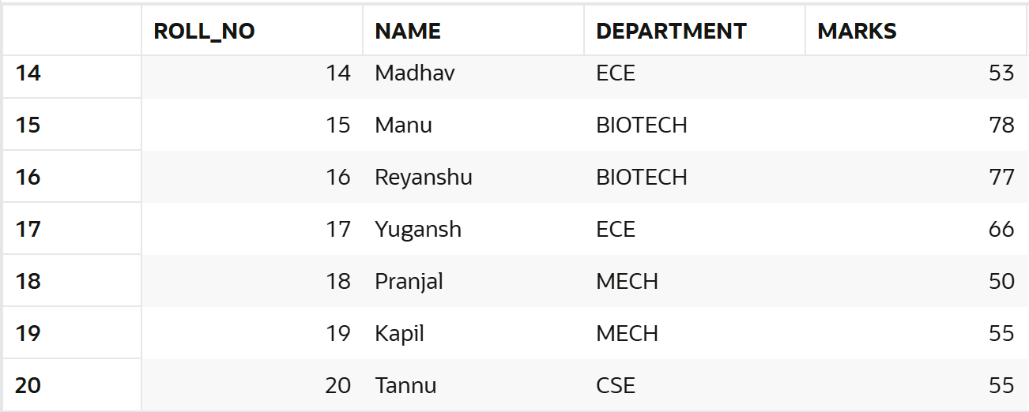

5. Delete rows from the table whose marks are same.

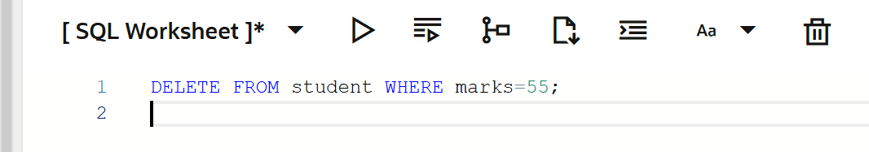

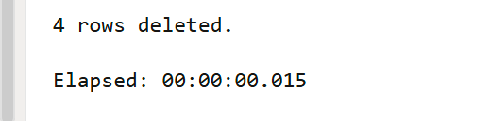

6. View the complete table

